1. **Agenda**:
   1. We want camel-microservice-a to put a msg on ActiveMQ Queue.
2. 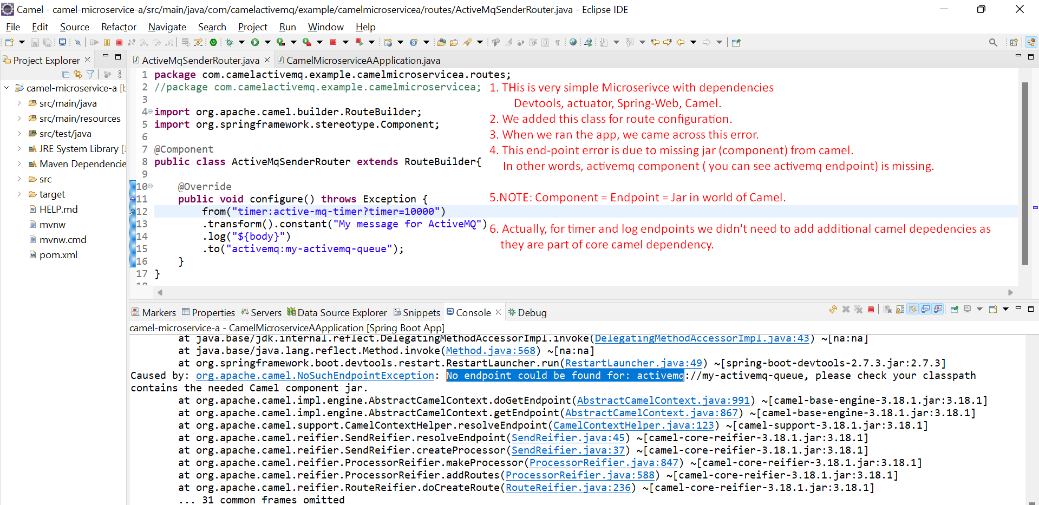
3. Graphical user interface, text, application

   Description automatically generated
4. Graphical user interface, text

   Description automatically generated
5. 
6. Graphical user interface

   Description automatically generated with low confidence
7. Connection creation to ActiveMQ is being done by **Spring Boot Auto-Configuration**.